**Assignment Day 6**

1. Categorize products by stock status

(Display product_name, a new column stock_status whose values are based on below condition

units_in_stock = 0 is 'Out of Stock'

units_in_stock < 20 is 'Low Stock')

select product_name,

Case

When units_in_stock = 0 Then 'Out of Stock'

When units_in_stock < 20 Then 'Low Stock'

Else 'In Stock'

End as stock_status

from products

2. Find All Products in Beverages Category

(Subquery, Display product_name,unitprice)

select product_name,unit_price

from products

Where category_id = (select category_id from categories where category_name = 'Beverages')

3. Find Orders by Employee with Most Sales

(Display order_id, order_date, freight, employee_id.

Employee with Most Sales=Get the total no.of of orders for each employee then order by DESC and limit 1. Use Subquery)

select employee_id,order_id, order_date, freight

from orders

where employee_id = (

select employee_id

FROM orders

GROUP BY employee_id

ORDER BY COUNT(employee_id) DESC

LIMIT 1

)

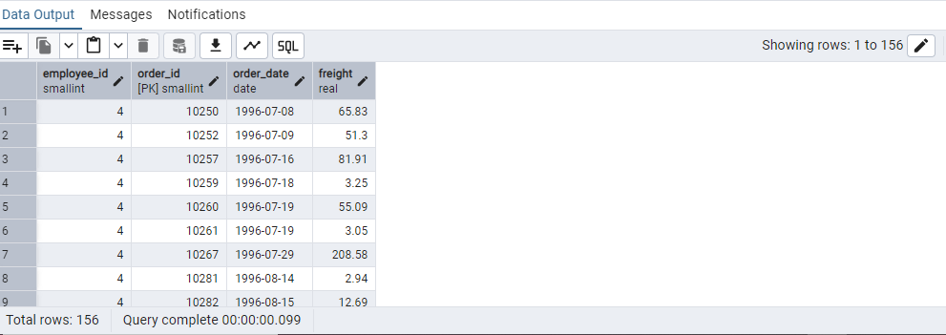

4. Find orders where for country!= ‘USA’ with freight costs higher than any order from USA. (Subquery, Try with ANY, ALL operators)

Subquery with Any

select order_id, order_date,freight,ship_country

from orders

where ship_country != 'USA'

and

freight > Any(select freight from orders where ship_country = 'USA')

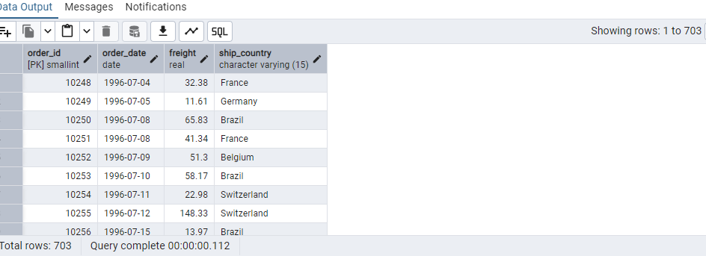

**Subquery with All**

select order_id, order_date,freight,ship_country

from orders

where ship_country != 'USA'

and

freight > All(select freight from orders where ship_country = 'USA')

